LEAVE OF EXCEPTIONAL CIRCUMSTANCE ABSENCE REQUEST FORM – BRANNEL SCHOOL

The law does not grant parents an automatic right to take their child out of school during term time. Any absence from school will disrupt your child’s learning. You may consider that a holiday will be educational, but your child will miss out on the teaching that their classmates will receive during your holiday. Attendance is vital to academic success and lost education poses a potential risk of underachievement. This is something we all have a responsibility to avoid.

The Department for Education no longer allows Headteachers to grant any leave of absence during term time unless there are exceptional circumstances. If you consider that your request for absence is exceptional you will need to complete the form attached to this notification. A response will be sent to you as soon as possible. If leave is not authorised and you nevertheless withdraw your child from school, the absence will be recorded as unauthorised absence.

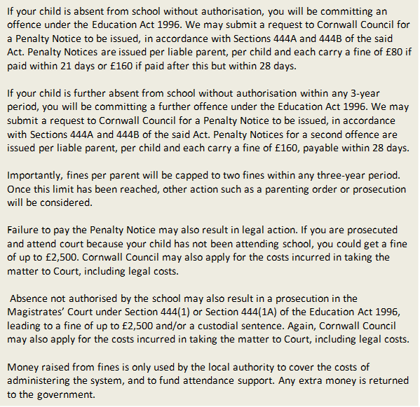

‘Parent’ as set out in Section 576 of the Education Act 1996, defines parent to include: natural parents, whether they are married or not; any person or body who has parental responsibility for a child (as defined by the Children Act 1989) and; any person who, although not a natural parent, has care of a child. Having care of a child means a person with whom a child lives and who looks after a child, irrespective of what their relationship is with said child.

All requests must be completed on this form; letters will not be accepted. This form should be returned to the Attendance Office at least 15 school days before the start of the absence.

I hope you will support our efforts in raising attendance and attainment at Brannel School.

APPLICATION BY PARENT/CARER

If you consider an absence during term time to be an exceptional circumstance, please complete this form and return it to the Attendance Office at least 15 school days before the date you wish to remove your child from school.

Child Name: ____________________________

Date Of Birth : ______________ Tutor Group/ Class: _____________

Home Address: ___________________________________________________________________

Post Code: ________________

Name of Parent/Carer completing this form: ___________________________________________

First day of absence: ___________________ Date of return to school: ___________________

If leaving your home address before the first day of absence, please provide the date on which

you will leave ___________________ Total number of days missed: _______ days

Name of sibling/s who attend a CELT School:

Child’s name(s): _________________________________________________________________

School(s): _______________________________________________________________________

Reason for absence: _______________________________________________________________

________________________________________________________________________________

________________________________________________________________________________

I understand that if the absence request is unauthorised the school may request that Cornwall Council issue a Penalty Notice. I understand that a Penalty Notice is issued to each liable parent/carer of each child taken out of school and that this carries a fine of £80 if paid within 21 days, increasing to £160 if paid within 28 days (or £160 with no option to pay the lower amount if it is the 2nd penalty notice within a rolling 3-year period). I understand that if I do not pay the fine, it may result in legal action being taken against me. I understand that parents have a duty to ensure their child’s regular attendance at school and failure to do so is an offence under Section 444(1) and Section 444(1A) of the Education Act 1996.

Signed ………………………………………………………………………
Dated ………………………………………………………….
(Please ensure you give at least 15 school days’ notice of the proposed absence)

Below to be completed by the school: FAO – Headteacher

% Current | % Last Year | Comments

Learners Name: …………………………………………………………

Tutor/Teacher: …………………………… Year: ……………...… Class:........

AUTHORISED: UNAUTHORISED:

Request has been authorised for the following dates only:

___ / ___ / _____ to ___ / ___ /_____

Signed …………………………………………………. Headteacher

Date ___ / ___ / ___

Letter sent / Phone Call / other | Signed: Date:
Action: PN Request | Signed: Date:

